FIRST CHURCH OF CHRIST IN LONGMEADOW
“Striving to be a Church the World needs Today”!

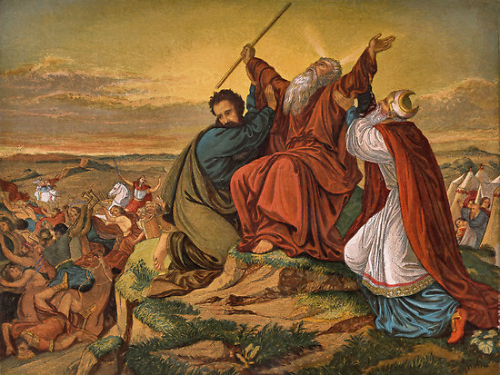

“The Ten Commandments”

ORDER OF WORSHIP
Thirteenth Sunday after Pentecost
August 23, 2026

Those who are able, please stand.

Prelude "Selah" Edwin Lemare
Welcome
Call to Worship
Leader: For Summer graces.
People: For Worship music.
Leader: For beaches and mountains and flowers.
People: For prayers asked and answered.
Leader: For a sense of peace.
People: And a sense of hope.
Leader: For all these things we give thanks.
People: And we Worship the One who offer them to us.

Opening Prayer

Sharing the Peace of Christ

Kids Camp Special Music “Pharaoh, Pharaoh”

Hymn #552 "From the Crush of Wealth and Power"
New Century Hymnal (Black). BRIDEGROOM

Scripture: Exodus 20:1-21 Stew Creelman
Reader: God is still speaking.
People: We are still listening.

Children’s Moment: Surprise Bag Children’s Message
(Children will go upstairs to church school after the message).

Sermon: “The Ten Commandments” Pastor Doug Bixby

Anthem "Oseh Shalom" N. Hirsch, Arr. E.B. Ginsberg
Carey Larsen, soprano

"Oseh shalom bimromav / Hu ya'aseh shalom aleinu / V'al kol yisrael / V'imru: Amen (May the One who causes peace to to reign in the high heavens / Let peace descend on us / And all of Israel / And let us say: Amen.)"

Joys, Concerns, and Pastoral Prayer

Lord’s Prayer (debts) Our Father, who art in Heaven, hallowed be thy name. Thy kingdom come, thy will be done on earth as it is in Heaven. Give us this day our daily bread and forgive us our debts, as we forgive our debtors. And lead us not into temptation but deliver us from evil. For thine is the kingdom and the power and the glory, forever and ever, Amen.

Announcements
Offering and Offertory "Barechu" Salamone Rossi
Carey Larsen, soprano

Doxology and Prayer of Dedication
Praise God from whom all blessings flow. Praise God all creatures here below. Praise God for all that love has done: Creator, Christ and Spirit One. Amen.

Hymn #394 "In Christ There Is No East or West"
New Century Hymnal (Black). McKEE

Benediction

Postlude "All Glory, Laud, and Honor" Arr. Cindy Berry
______________________________________________________

The flowers on the Altar are in loving memory of Bill’s parents, Stephanie and William, Sr. They were given by Karen & Bill Rafferty.
Family Ministries Ice Cream Outing


Our next Family Ministries activity will be at Fenway Golf, 112 Allen St, East Longmeadow. We will meet at 2pm on Sunday, Aug. 30, for an afternoon of ice cream and miniature golf. Come join us for either (or both) activities! Let's get together for an end of summer church event and enjoy some ice cream and (maybe) a family-friendly mini golf competition.
http://www.fenwaygolf.com/

________________________________________________________________ Family Ministries Summer Travel Activity
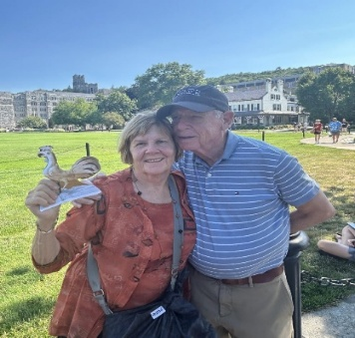
We invite you to take a Summer photo of yourself with our church rooster! Pick up a picture of our rooster in our library or the front entrance to the church and send to marilyn@firstchurchlongmeadow.org and say where the picture was taken (and what it is, if it's not self-explanatory). We'll post the pictures on Facebook again and in the bulletin and newsletter.
Westpoint
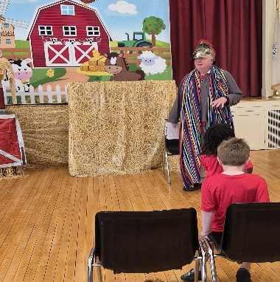
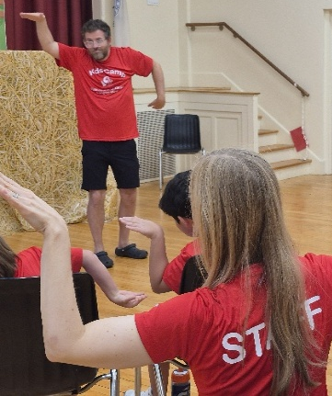
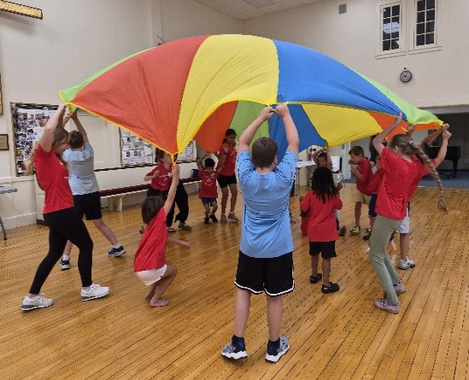
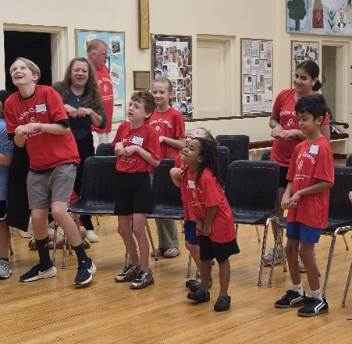
2026 Kids Camp! We all had a blast!
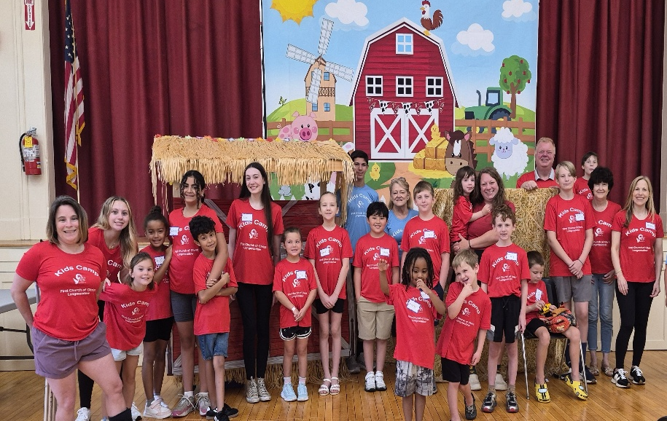

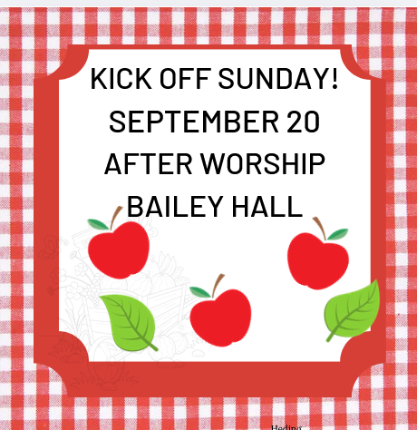
___________________________________________________
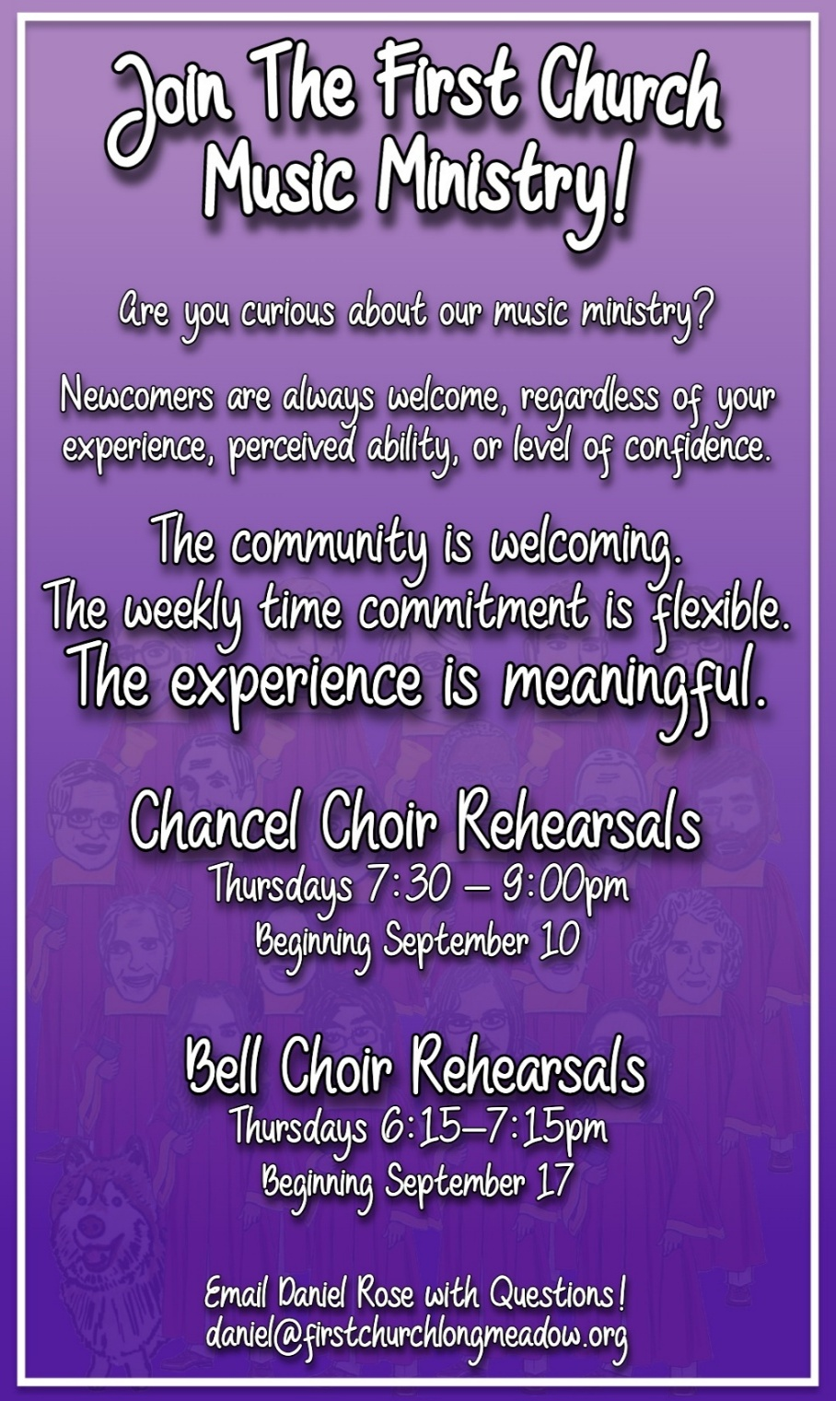
TODAY
Worship, Sanctuary, 10 am
Lemonade, After Worship, Bailey Hall

THIS WEEK

Monday – Prayer Shawl Group, Buxton Room, 10 am – Noon

Tuesday - EJT Meeting, Buxton Room, 7 pm

Wednesday – Leadership Meeting, Buxton Room, 6:30 pm

MARK YOUR CALENDAR

Chancel Choir Rehearsal, September 10, 7:30 pm – 9 pm
(Choir Room)

Jean Rogér Memorial, Memorial Garden, September 11

Annual Longmeadow Pride, Town Green, September 13
(First Church of Christ Open & Affirming Sunday).

Stewardship Meeting, Buxton Room, September 15, 4 pm

WBS Meeting, Women’s Benevolent Room, September 16, 2 pm

Bell Choir Rehearsal, September 17, 6:15 pm – 7:15 pm
(Choir Room)

Kick-Off Sunday! September 20, Bailey Hall, after Worship

More than Mom Clothing Swap, September 26, Bailey Hall

Annual CROP Walk, Forest Park, October 4, 1:30 pm

