FIRST CHURCH OF CHRIST IN LONGMEADOW
“Striving to be a Church the World needs Today!”

TOGETHER WE MAKE
A DIFFERENCE


“The Future Matters!”

ALL SAINTS & STEWARDSHIP SUNDAY
ORDER OF WORSHIP

November 1, 2026

Those who are able, please stand.

Prelude "Piano Sonata 11, Movement 1" Wolfgang Amadeus Mozart, Sophie, piano

Welcome Rev. Doug Bixby

Call to Worship (Hebrews 12:1-3)
Leader: In the beginning, God called the world into being, saying,
People: “Let there be light!”
Leader: In the fullness of time, Jesus came into this world, saying,
People: “I am the light of the world”
Leader: In our everyday lives, we see the work of the saints,
People: The ones in whom God’s light shines.
Leader: So let us give thanks for the saints this day
People: And let us worship God.

Opening Prayer & Sharing the Peace of Christ

Hymn #299 "For All the Saints" New Century Hymnal (Black) SINE NOMINE

Prayers of Remembrance Rev. Doug Bixby
Robert Spaulding Kenneth Kinsley
Betsy Sandow Spry Donald Muson
William Harbison Olga Mazzarino
Carey Miller Gloria Hildreth
David Peak Maria Cantos
Pauly Sample Robert Glasgow
Stephan Platzer Brian Edgerly
Elizabeth Lincoln Gay Wesson
Carroll Comstock

Scripture: Matthew 25:14-30 Liturgist, Wanona Dobbs
Reader: God is still speaking.
People: We are still listening.

Children’s Moment: A Message for all ages.
Children remain with their families on Communion Sundays.
Sermon: “The Future Matters” Rev. Doug Bixby

Anthem "They'll Know We Are Christians By Our Love"
Peter Scholtes, Chancel Choir
"We are one in the Spirit; we are one in the Lord; and we pray that all unity may one day be restored; and they'll know we are Christians by our love. We will walk with each other; we will walk hand in hand; and together, we will spread the news that God is in our land; and they'll know we are Christians by our love. We will work with each other; we will work side by side; and we'll guard each one's dignity and save each one's pride; and they'll know we are Christians by our love. All praise to the Father from whom all things come, and all praise to Christ Jesus, his only son; and all praise to the Spirit who makes us one; and they'll know we are Christians by our love."

Joys, Concerns, and Pastoral Prayer

Lord’s Prayer (debts)
Our Father, who art in Heaven, hallowed be thy name. Thy kingdom come, thy will be done on earth as it is in Heaven. Give us this day our daily bread and forgive us our debts, as we forgive our debtors. And lead us not into temptation but deliver us from evil. For thine is the kingdom and the power and the glory, forever and ever. Amen.

Prayer Response #812 "Amen (Danish)" New Century Hymnal (Black).
Call to Communion Rev. Doug Bixby
Prayer of Confession (in unison)
God of all the saints, God of all the sinners, hear our prayers. We would be saintlike – holy, good, patient, and loving. But we end up feeling more like sinners – full of failures, flaws, and self-centeredness. Perhaps you see us as simply human – as beloved, imperfect people; always trying, failing, and succeeding. In all of this, forgive the wrong we have done, and bless the good we have accomplished. Keep on loving us, helping us, and molding us into the people you want us to be and into the image of Christ within and around us, in whose name we pray. Amen!

Assurance of Pardon
Friends, in Christ, know this: the mercy of God is from everlasting to everlasting, and I remind you of the surpassing value of this grace – in Jesus Christ, we are forgiven. Alleluia! Amen.

Words of Institution

Sharing of the Bread and the Cup
Our communion bread is gluten free.

Communion Music "From This Table" Francis Patrick O'Brien
Chancel Choir
Prayer of Thanksgiving

Announcements and Call to Offering

Offertory "Allerseelen" Richard Strauss, Mark Todd, tenor

Doxology: Praise God from whom all blessings flow. Praise God all creatures here below. Praise God for all that love has done: Creator, Christ and Spirit One. Amen.

Prayer of Dedication

Hymn #399 "When Minds and Bodies Meet as One" v. 1,3,5
New Century Hymnal (Black). TRINITY CAROL
Benediction

Postlude "When I Can Read My Title Clear" Arr. Faye López
______________________________________________________
Online giving is available. Thank you for your continued support!


The flowers on the Altar today are given in loving memory of our Mom and Dad, Bev and Bob Gray and our grandparents, Peck and Mable Sanford. They were given by June and George.

The flowers were arranged
by Marieke Burt.
______________________________________________________
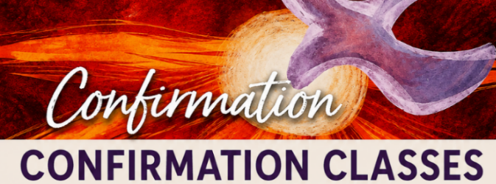
TODAY AFTER WORSHIP
Taught by Pastor Doug and Wanona!

The classes are 11:30 am -12:30 pm, upstairs
in the Atwater Room.
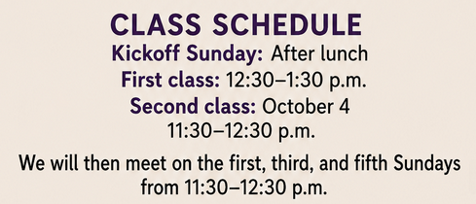
______________________________________________________
November 8 — Commitment Sunday
Bring your pledge card to worship as, together, we joyfully offer our pledges for 2027. Afterward, celebrate at our
Commitment Brunch in Bailey Hall!
This Photo by Unknown Author is licensed under CC BY-NC

This Photo by Unknown Author is licensed under CC BY-NC
Today in the Sanctuary at 11:30 am.
Children's Christmas Pageant!

It's time to prepare for the annual Children's Christmas pageant! This year the pageant will be held on Dec. 20th, which is the 4th Sunday of Advent, during our regular Sunday worship.
The rehearsal schedule is as follows:

November 15, 29
December 6 & 13
December 20 - Pageant Day!
If your child(ren) will be available on Dec. 20th and are interested in participating in the pageant, please let Marilyn know. Pageant roles are open to children 3 years old up through 5th grade.
Rehearsals are at 11:30am in the sanctuary. Please plan to attend as many rehearsals as possible. As you can see by the schedule, there are only 4 rehearsals before the pageant.
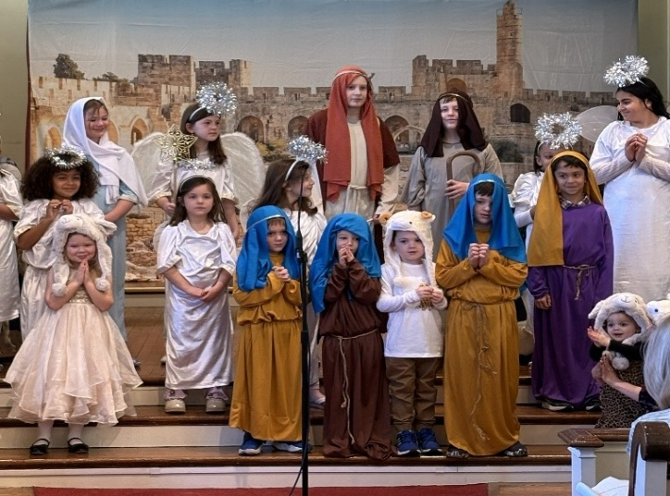
Please contact Marilyn at marilyn@firstchurchlongmeadow.org with any questions.
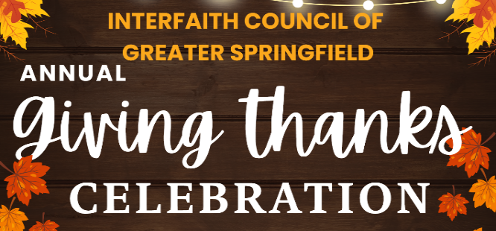
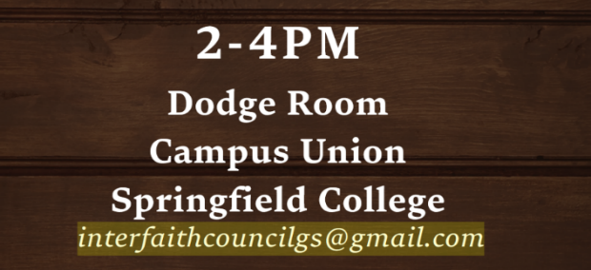
Today!
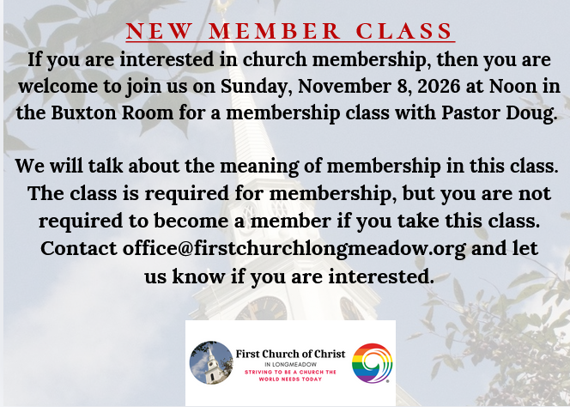
________________________________________
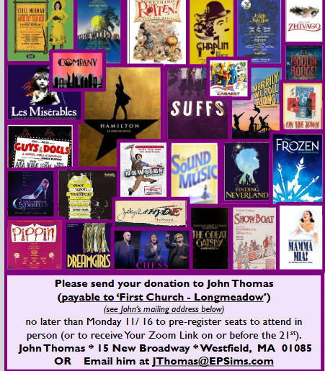
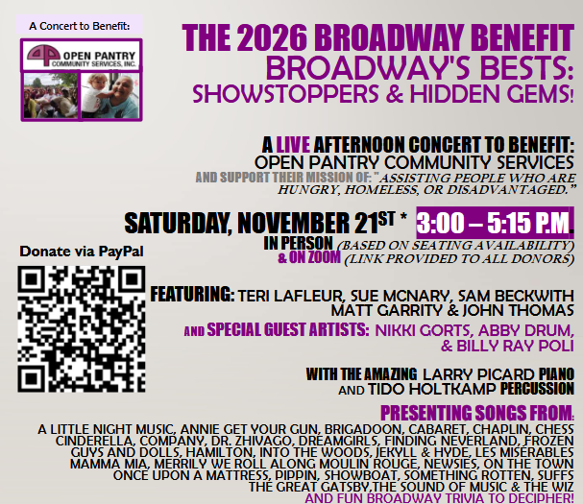

Location: First Church, Longmeadow, Bailey Hall, 3 pm.
& livestreamed on Zoom. The link is mailed to donors before 11/21.
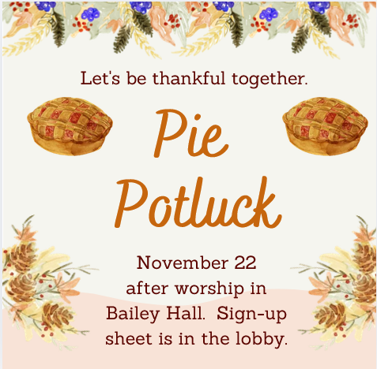
______________________________________________________

Gently used items may be dropped off in the bin at the Williams St. entrance. Thank you for your support in keeping our community warm!

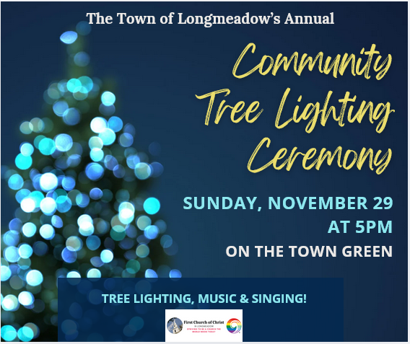
________________________________________________
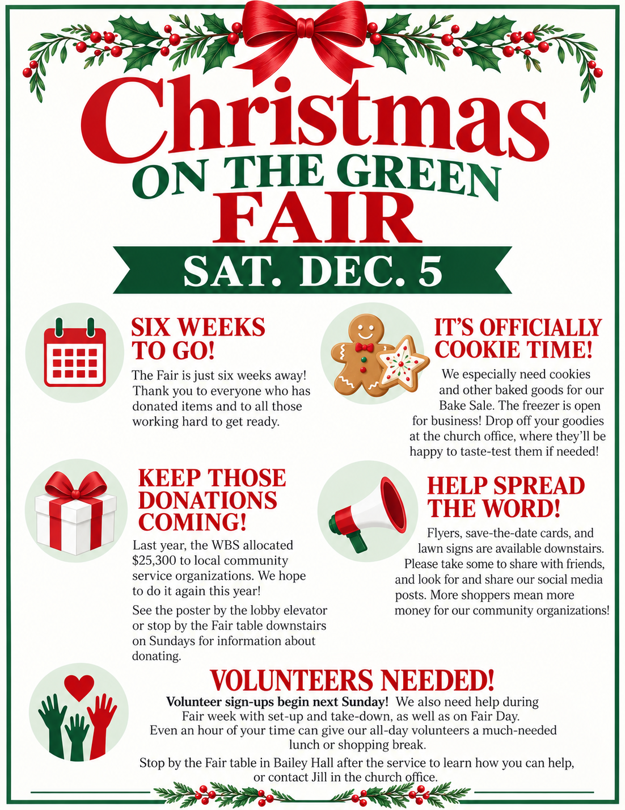

Church office 413-567-6287
TODAY
Worship, Sanctuary, 10 am
Stewardship Sunday,
Please remember to pick up your stewardship packet, including
your 2027 pledge card today. Thanks!
Coffee Hour after Worship, Bailey Hall
Children’s Pageant Rehearsal, Sanctuary, 11:30am
Confirmation Class, Atwater Room, 11:30am
Interfaith Council of Greater Springfield, Springfield College, 2pm
Broadway Benefit Rehearsal, Bailey Hall, 6pm – 8pm

THIS WEEK
Monday: Broadway Benefit Interview, Mass Appeal, NBC, 11am
Broadway Benefit Rehearsal, Bailey Hall, 5:30pm – 7:30 pm

Tuesday: Vote! Vote! Vote!
Social Justice will meet November 10, after the Deacons Mtg.

Wednesday: Christmas on the Green Fair Meeting
Benevolent Room, 2:00 pm

Thursday: Spirit Speaks, Study, 4:15 pm

Bell Choir Rehearsal, Choir Room, 6:15 pm – 7:15 pm
Chancel Choir rehearsal, Choir Room - 7:30 pm - 9:00 pm

MARK YOUR CALENDAR
- More Than Mom Toy Swap, November 7, Bailey Hall, 10 am
- Commitment Sunday & Brunch, November 8
- New Member Class, Buxton Rm, November 9, Noon
- Broadway Benefit, Bailey Hall, November 21, 3 pm
- Witness Stones Meeting, Atwater Room, December 2 (tbd.)
- Christmas On The Green Fair, Saturday, December 5, 9-3 pm
- Children’s Christmas Pageant, Sanctuary, December 20, 10 am

