FIRST CHURCH OF CHRIST IN LONGMEADOW
“Striving to be a Church the World needs Today”!



“SPEAKING TRUTH TO POWER”

ORDER OF WORSHIP
Eleventh Sunday after Pentecost
August 9, 2026

Those who are able, please stand.

Prelude "Supplication" Alexander Schreiner
Welcome
Call to Worship
Leader: Come, brothers and sisters let us pray together,
People: For our God is a listening God.
Leader: Let us sing together,
People: For our God is a joyful God.
Leader: Let us give thanks together,
People: For our God is a generous God.
Leader: Let us rejoice together,
People: For our God is a loving God.

Opening Prayer

Sharing the Peace of Christ

Hymn #572 "When Israel Was in Egypt's Land"
New Century Hymnal (Black). GO DOWN, MOSES

Scripture: Exodus 6:28-7:7 Wanona Dobbs
Reader: God is still speaking.
People: We are still listening.

Children’s Moment: Surprise Bag Children’s Message
(Children will go upstairs to church school after the message).

Sermon: “Speaking Truth to Power” Pastor Doug Bixby

Anthem "Find Us Faithful" Jon Mohr
Sue McNary, mezzo-soprano

Joys, Concerns, and Pastoral Prayer

Lord’s Prayer (debts) Our Father, who art in Heaven, hallowed be thy name. Thy kingdom come, thy will be done on earth as it is in Heaven. Give us this day our daily bread and forgive us our debts, as we forgive our debtors. And lead us not into temptation but deliver us from evil. For thine is the kingdom and the power and the glory, forever and ever, Amen.

Announcements

Offering and Offertory "Beside Still Waters" Adolph Hesse

Doxology and Prayer of Dedication
Praise God from whom all blessings flow. Praise God all creatures here below. Praise God for all that love has done: Creator, Christ and Spirit One. Amen.

Hymn #539 "Won't You Let Me Be Your Servant"
New Century Hymnal (Black). SERVANT SONG

Benediction

Postlude "We Shall Overcome" Arr. Albert Mendoza
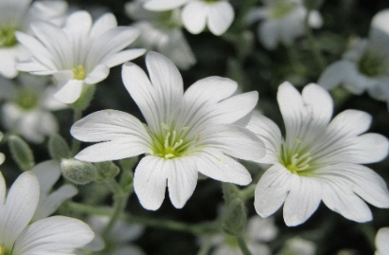
______________________________________________________

Please enjoy the beautiful flowers on the Altar. They were arranged by Kathleen Brindle and Donna Young.

Family Ministries Summer Travel Activity
As you go on your vacations this summer, we invite you to take a photo of yourself with our church rooster!
Pick up a rooster picture in our library or the front entrance to the church. Send your picture to marilyn@firstchurchlongmeadow.org
and say where the picture was taken (and what it is, if it's not self-explanatory). We'll post the pictures on Facebook again and in the bulletin and newsletter.
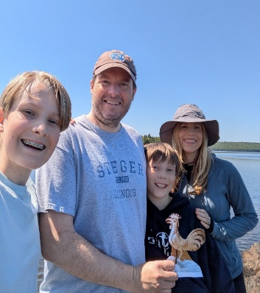
Maine
______________________________________________________
Crucial conversation here from Noelia.

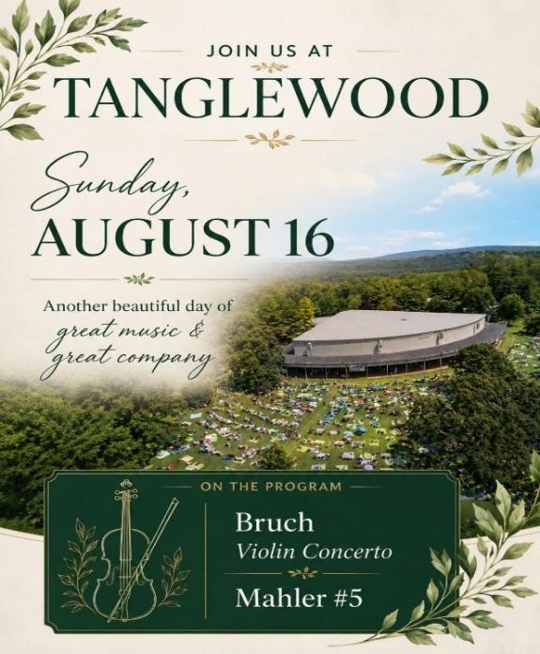
______________________________________________________
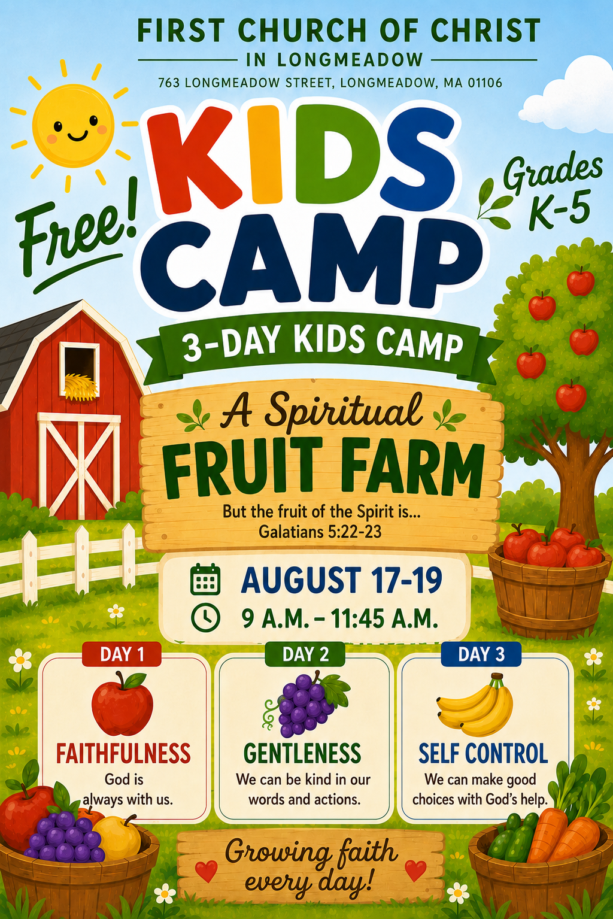

Our first Christmas on the Green Fair planning meeting will be held on Wednesday, August 12, at 2:00 p.m. in the Benevolent Room. Anyone interested in helping plan this year's fair is warmly invited to join us!

Starting in September, we will begin accepting donations of gently used to new items, as well as antique and vintage treasures. We welcome donations including:
- Art
- Books and book-related items (no text books or mold please)
- Household items and décor
- Christmas decorations
- Toys, puzzles, and games & "Attic treasures" (this and that!) Please continue creating your handcrafted treasures for our First Church Originals table. Handmade items may be left in the church office at any time throughout the year.
Jewelry is always a best seller! Jewelry donations may also be brought to the church office at any time. If you are cleaning out your home, downsizing, helping someone move, or otherwise have items you'd like to donate before September, please contact Jill in the church office to arrange an early drop-off. 413-567-6287.
TODAY
Worship, Sanctuary, 10 am
Lemonade, After Worship, Bailey Hall
Crucial Conversation with Longmeadow Future Building Use Task Force, after Worship, Buxton Room, 11:30 am

THIS WEEK

Tuesday - Called To Care, Buxton Room, 4:15 pm

Deacons Meeting, Buxton Room, 5:30 pm

Wednesday – Women’s Benevolent Mtg., WBS Rm, 2 pm - 4 pm

Monthly Men’s Group, Buxton Room, 7 pm

MARK YOUR CALENDAR

Tanglewood, August 16

Kids Camp, August 17 – 19
(9 am – 11:45 am
(Registration is required.)
Kids Camp registration forms are in the Narthex or the Church Library. marilyn@firstchurchlongmeadow.org with any inquiries.

Leadership Meeting, August 26, Buxton Room, 6:30 pm

Annual Longmeadow Pride, Town Green, September 13
(First Church of Christ Open & Affirming Sunday)

Kick-Off Sunday! September 20, Bailey Hall, after Worship
(Details to follow shortly)

Annual CROP Walk, Forest Park, October 4

